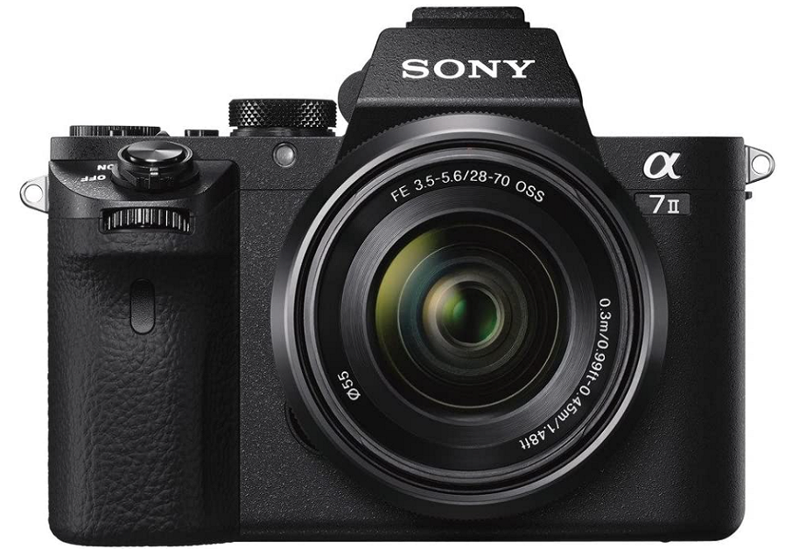

**Sony Alpha a7 IIK E**

* **World’s first 5 axis in body image stabilization in a full frame camera**
* **Use your favorite lenses without blur from camera shake; High 50 Mbps bit rate XAVC S21 format recording of Full HD movies**
* **Capture stunning images with full frame, 24.3MP resolution. Lens Compensation: Peripheral shading, chromatic aberration, distortion**
* **Fast hybrid AF with phase detection: 30 percent faster than a7**
* **Compatible with Sony’s E mount lenses, and others with adaptors**
* **Price $1,598.00**